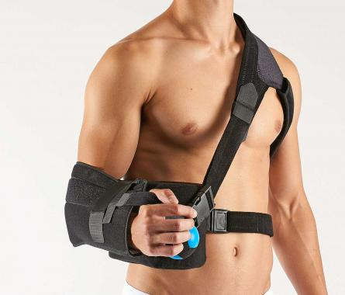

**Shoulder abduction orthosis**

**OR2F**

You will need the help of a second person to put this product on.

Make sure all straps are open.

Wrap the abduction wedge around your waist using the body strap.

For this purpose thread the strap through the plastic loop and fasten it using the Velcro fastener.

The wider part of the cushion should face forward (Fig. 1).

Put the injured arm into the arm cuff intended for this purpose and attach it to the abduction wedge using the Velcro fastener (Fig. 2).

Attach the thumb strap located between thumb and index finger to the cuff and wedge.

Now, put the Y strap including shoulder padding on the healthy shoulder.

Fasten strap A (Fig. 3) to the abduction wedge (Fig. 4) using the quick fastener.

Pull strap B (Fig. 3) with its armpit padding out from under the armpit (Fig. 5) and thread it through the plastic loop on the back of the abduction wedge. After that fasten strap B using the Velcro fastener (Fig. 6).

Thread strap C (Fig. 3) through the plastic loop on the back of the arm cuff, fold the strap back and close it using the Velcro fastener (Fig. 6).

The straps can be shortened in case they are too long.

Squeezing the enclosed ball promotes blood circulation in the injured arm.

To ensure optimum fit, you can re-adjust the Velcro fasteners

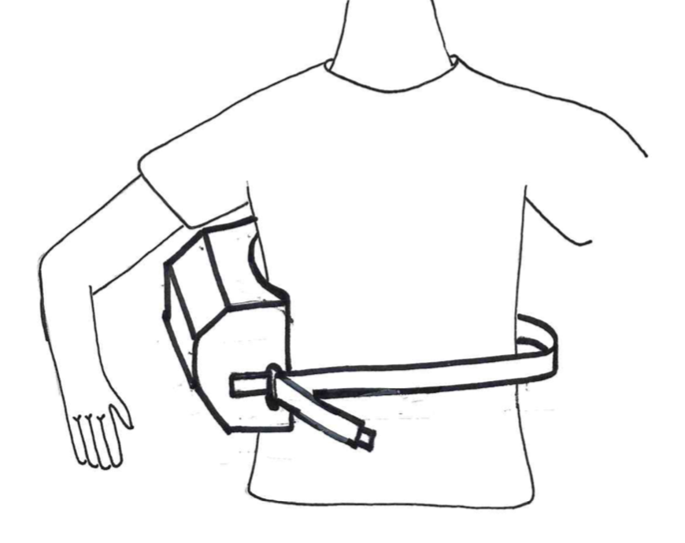

Fig. 2

Fig. 1

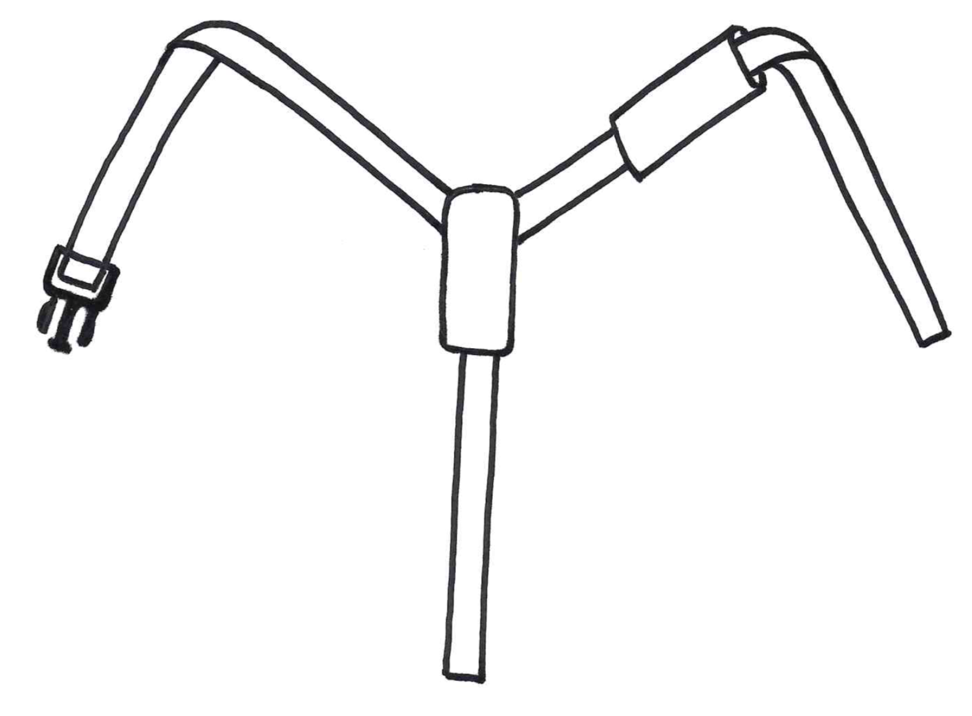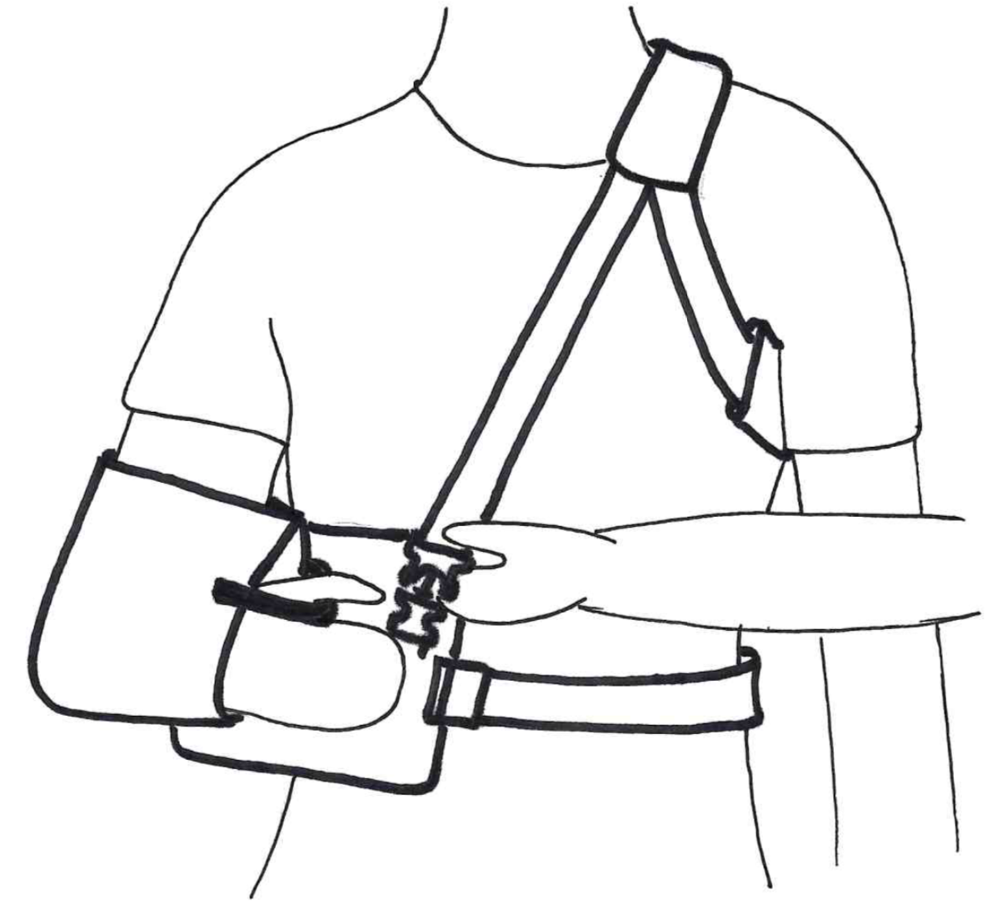

A

A

B

C



**Schaper Healthcare GmbH**

Vogelweiderstraße 146 |4600 Wels | Austria

[office@schaper-healthcare.at](mailto:office@schaper-healthcare.at) | [www.schaper-healthcare.at](http://www.schaper-healthcare.at)

T +43 7242 252 965

Version 08/2019

Note: All serious incidents connected to the product must be reported to the manufacturer..

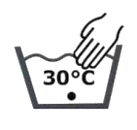

Indications:

Conservative treatment of anterior and posterior shoulder luxations, after posterior shoulder stabilisation surgery

Application instructions:

This product is solely intended to be used on one patient.

If you are unclear or have any questions about the product and its use, please contact your doctor or qualified personnel.

Storage instructions:

Don’t expose the product to direct sunlight. Store in a dry place protected from sunlight.

Disposal instructions:

This product can be disposed of in regular household waste.

C

B



B

Front view

Fig. 5

Rear view

Fig. 6

Fig. 4

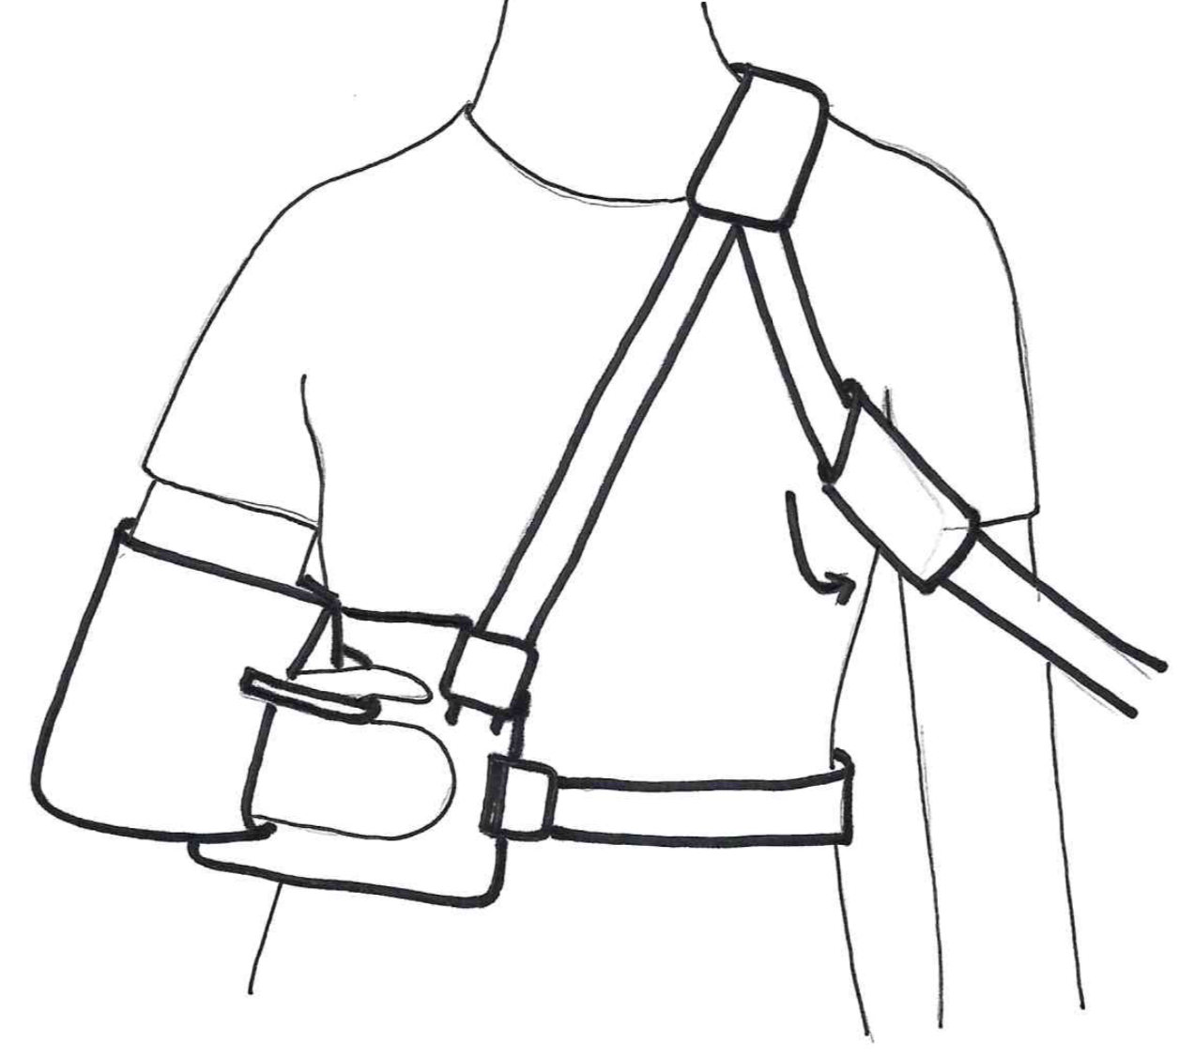

Fig. 3